Metadata and thumbnails for Red folder of photos

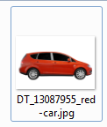

Caption ID of Parent: 1353819

Source: Dreamstime

Source ID: 13087955

Rights Type: Royalty Free

Credit: © Goce/Dreamstime.com

K12 Credit: New red caravan car. © Goce/Dreamstime.com

RM Assets Embedded: No

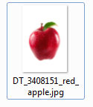

Caption ID of Parent: 221222

Source: Dreamstime

Source ID: 3408151

Rights Type: Royalty Free

Credit: © Olga Lyubkina/Dreamstime.com

K12 Credit: Red apple. © Olga Lyubkina/Dreamstime.com

RM Assets Embedded: No



Caption ID of Parent: 219172

Source: Dreamstime

Source ID: 6071617

Rights Type: Royalty Free

Credit: © Le Do/Dreamstime.com

K12 Credit: Ladybug. © Le Do/Dreamstime.com

RM Assets Embedded: No

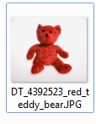

Caption ID of Parent: 116491

Source: Dreamstime

Source ID: 4392523

Rights Type: Royalty Free

Credit: © Nikopolis/Dreamstime.com

K12 Credit: Jojo makes people happy. © Nikopolis/Dreamstime.com

RM Assets Embedded: No

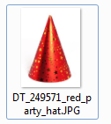

Caption ID of Parent: 116487

Source: Dreamstime

Source ID: 249571

Rights Type: Royalty Free

Credit: © Edyta Pawlowska/Dreamstime.com

K12 Credit: Party hat. © Edyta Pawlowska/Dreamstime.com

RM Assets Embedded: No

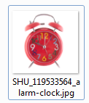

Caption ID of Parent: 1350191

Source: Shutterstock

Source ID: 119533564

Rights Type: Royalty Free

Credit: © wong yu liang/Shutterstock

K12 Credit: Alarm clock. © wong yu liang/Shutterstock

RM Assets Embedded: No



Caption ID of Parent: 1346754

Source: Shutterstock

Source ID: 23863657

Rights Type: Royalty Free

Credit: © Evgeni_S/Shutterstock

K12 Credit: Red rose with bud. © Evgeni_S/Shutterstock

RM Assets Embedded: No

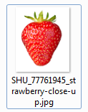

Caption ID of Parent: 1346722

Source: Shutterstock

Source ID: 77761945

Rights Type: Royalty Free

Credit: © Picsfive/Shutterstock

K12 Credit: Strawberry. © Picsfive/Shutterstock

RM Assets Embedded: No

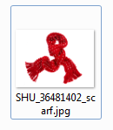

Caption ID of Parent: 1300040

Source: Shutterstock

Source ID: 36481402

Rights Type: Royalty Free

Credit: © kedrov/Shutterstock

K12 Credit: Knitted scarf. © kedrov/Shutterstock

RM Assets Embedded: No